Riba Free Economy as the Enabler of Halal Eco-System
(10 pt blank line)
Zulkarnain Yusoff¹, Muslim Ismail@Ahmad^{2*,} Roslina Othman³, Mohd Nasir Ismail⁴,
Mohd Saufi Ismail⁵
(10 pt blank line)
^{1,5}Academy of Contemporary Islamic Studies, Universiti Teknologi MARA Kelantan,
18500 Machang, Kelantan, MALAYSIA
zul713@kelantan.uitm.edu.my
saufi408@kelantan.uitm.edu.my
²Tengku Anis Library, Universiti Teknologi MARA Kampus Kota Bharu,
15050 Kota Bharu, Kelantan, MALAYSIA
muslim368@kelantan.uitm.edu.my
³Kulliyah of Information, Communication and Technology, International Islamic University Malaysia,
53100 Gombak, Selangor, MALAYSIA
roslina@iium.edu.my
⁴Faculty of Information Management, Universiti Teknologi MARA Kelantan,
18500 Machang, Kelantan, MALAYSIA
nasir733@kelantan.uitm.edu.my
*Corresponding Author
(10 pt blank line)
(10 pt blank line)
Abstract: This research applies bibliometric tool in analyzing riba free or halal economy in research available in online databases. Dataset are citations from Scopus, ProQuest and ScienceDirect. Triple element mapping review is used to establish concept definition. Conceptual definition surrounding riba, usury and interest are highlighted and debated in literature. The aim of this research is to analyze subject relation of halal economy as the enabler of halal eco-system. VOSviewer, GEPHI, JabRef and Microsoft® Excel is used as tool of bibliometric visualization and data statistical analysis. Datasets are citations from Scopus, ProQuest and ScienceDirect databases. From Scopus database, 130 journal articles were obtained ranging from 1982 to 2018, from ProQuest 646 citations ranging from 1989 to 2018 and from ScienceDirect 313 citations of 26 years (1993-2019). Total citation datasets 1,089 with a time span of 27 years. Analysis result are divided into clusters of co-occurrence of index term in titles and abstracts. Authors with the highest citation link is also highlighted and highest output journal is also outlined.

(10 pt blank line)
Keywords: Riba free, halal economy, halal cluster, bibliometric

- Introduction

The question of riba in banking and financial transactions is conterversial issue among scholars and the Muslim general public. Riba in this research refers to the excessive payment in loans or mortage transactions. The excessive rate quantity is a hot debate among scholars and jurists. This research undertook a bibliometric analysis in Scopus, ProQuest and ScienceDirect databases to explore the availability and subject relation of riba in the context of halal cluster. Halal as a multi billion industry exists in a sustainable eco-system as stressed by Marco (2015). Halal clusters refers to elements that enables the economic production, manufacturing, distribution, logistics, warehousing and all other economic activities in a sustainable and credible eco-system. Financial aspects must be free from any form of haram in order for the suppliers and manufacturers to provide halal product. In this research, bibliometric method is applied from datasets accessed from three databases and structured analysis is used to understand the concept of riba as a forbiddance in Islam. With the concept established, operational definition is created and index term is used in the retrieval process.

Analysis of citation data is done using VOSviewer and for data crosschecking purposes GEPHI, JabRef and Microsoft® Excel is also used. The research flowchart are as follows:

Figure 1: Research Flowchart

2. Methodology

This research used a mixed of qualititative and quantitative method in which bibliometric study is used. The research is an exploratory sequential model in which qualititative data precedes quantitative data, (Creswell, 2014). Datasets are citations from Scopus, ProQuest and ScienceDirect in the form of journal articles in English language. The time range differs due to availability in respective databases. Time range in Scopus is 36 years (1982-2018), ProQuest data time range is 29 years (1989-2018) and ScienceDirect data time range is 26 years (1993-2019). The research begins with concept operational definition and with triple element systematic mapping review of the concept of halal in Islam. From the definition and reviews, established index term can be used in information retrieval process. The following search strategy was used in Scopus:

TITLE-ABS-KEY ( riba ) AND ( LIMIT-TO ( DOCTYPE , "ar" ) ) AND ( LIMIT-TO ( LANGUAGE , "English" ) ) AND ( LIMIT-TO ( SUBJAREA , "SOCI" ) OR LIMIT-TO ( SUBJAREA , "ECON" ) OR LIMIT-TO ( SUBJAREA , "BUSI" ) )

In ProQuest, keyword ‘riba’ was used and document set for scholarly journals, language set for English and the following subject was ticked:

Islamic financing OR banking industry OR islam OR Islamic law OR Muslims OR banks OR financial institutions OR religion OR economics OR ethics OR economic crisis OR economic theory OR interest rates OR financial services OR regulation of financial institutions OR securities markets OR business ethics OR economic models OR economic growth OR project finance OR marketing OR microfinance OR construction industry OR international finance OR poverty OR banking OR corporate governance OR koran OR economic development OR profits OR consumer behavior OR consumers OR morality OR capital markets OR central banks OR investment policy OR macroeconomics OR religious law OR entrepreneurs OR equity OR commercial banks OR financial instruments OR gross domestic product--gdp OR home financing OR political economy OR economic statistics OR entrepreneurship OR finance OR law OR low income groups OR asset backed securities OR bank marketing

In ScienceDirect, the keyword ‘riba’ was also used and set for research articles. Languages other than English was filtered and the following journal titles was chosen:

Pacific-Basin Finance Journal, Procedia - Social and Behavioral Sciences, Borsa Istanbul Review , Journal of Economic Behavior & Organization, Research in International Business and Finance, Procedia Economics and Finance, Journal of International Financial Markets, Institutions and Money, The Quarterly Review of Economics and Finance, Economic Modelling, World Development

The research utilizes rigorous and repeated process of checking and crosschecking data and statistic. The goal is to identify index term connection and subject relation in clusters. The bibliometric used here is co-occurrence of words or terms from data corpus, specifically from titles and abstract. A mapping review of a triple element of Arabic English translation semantic in relation to Islamic knowledge and Information Retrieval (IR) is done to synthesize the context of riba in English and researches.

3. Triple Element Mapping Review of Arabic English Translation Semantic

Islamic knowledge IR in databases essential requires understanding its history, language, religion and culture. Thus, a triangulation of information is needed to map the actual problem of IR of Islamic knowledge. Arabic language concept of meaning depends heavily on root structure of words, generally from three letters or more, (Alao, 2015). Concept of meaning not only depends on root structure but also on dimensions of meaning based of the speakers intention. This is what Kamali (2000) expressed in his commentaries on fundamentals of Islamic jurisprudence based on the verses of the Quran. Also, translation process in any language from other language would likely to experience the emotive nature of ‘lost in translation’. ‘Lost in Translation’ is a factor when translating different language with contrasting cultures, geographical boundaries, and religion. In achieving fruitful communication between any two different linguistic codes, full command of the two languages is an essential requirement and highly needed. Technically, the original language are called the source language (SL) and the translated version is the target language (TL). Indeed, absence or lack of such understanding would pose predicament in transferring the intended meaning from one language to another. Consequently and inevitably, losses could occur and hence, Lost in Translation. Therefore, any translation process should ensure that the target text (TT) presents the key elements of the source text (ST) by incorporating it well into the incipient product to produce the same effect as was intended by the ST, (Abdelaal & Rashid, 2015).

Arabic has always been the lingua franca of Islam since its inception 1400 years ago. More than a billion Muslim around the world recite the Quran daily in Arabic and Islam has influenced the languages of many countries including parts of Africa and the Malay Peninsula. Arabic language itself is a very rich and precise language. Arabic forces its speaker to use intellect more than any other most languages in the world. One of the reason for such a necessity is that most Arabic words has a concept of meaning based on concept of root structure, (Alao, 2015). Historically, Arabic is a Semitic language that works on a root system in which words are derived from a set root of consonants that contain the base meaning of the word. These root consonants are put into methodological patterns which morph the meaning of the root to create a variety of related meanings. From these principles, new meaning can be derived from the morphed pattern. To understand the concept of root system, it is important the letters must always be in the same order for example, from three letters of Kaf (ﻚ), Ta’ (ﺕ) and Ba’ (ﺐ) the following words can be created:

Table 1: Arabic Language Root Word Concept of Meaning

Arabic | كتب | يكتب | بكتب | كتاب | كاتب | مكتبة
Transliteration | Kataba | Yaktub | Maktab | Kitaab | Kaatib | Maktaba
Translation | He wrote | He writes | Office/Desk | Book | Writer/author | Library

Quran as the main reference of Islamic knowledge and the main method of extracting principles of Islamic ruling is known as Usul al-Fiqh (principles of Islamic jurisprudence). Kamali (2000) categorized wording in the Quran verses into clear and unclear words. Specifically, the words referred by Kamali (2000; pg 93) are those which are unique to Islam such as salah, zakah, hajj and riba. Kamali regarded such terms as unclear and unequivocal which means that the verses are inadequate to be understood on its own and thus, requires reference to the Hadith to explain the subject.

Table 2: Quran Verse 2:275 on Prohibition of Riba

Quran Original Text | Transliteration | Translation | Semantic Loss
Without tashkeel  وأحل الله البيع وحرم الربا | waahalla Allahu albayAAa waharrama arriba | Pickthall  “Whereas Allah permitteth trading and forbiddeth usury” | Shift in Meaning  [الربا translated as usury]
 |  | Yusuf Ali  “But Allah hath permitted trade and forbidden usury” | Shift in Meaning  [الربا translated as usury]
With tashkeel  وَأَحَلَّ اللَّهُ الْبَيْعَ وَحَرَّمَ الرِّبَا |  | Shakir  “And Allah has allowed trading and forbidden usury” | Shift in Meaning  [الربا translated as usury]
 |  | Dr Ghali  “And Allah has made selling lawful, and has prohibited riba” | Consistent Meaning  [الربا translated as riba]

3. The Riba, Usury and Interest Debate

Literally, riba in Arabic means ‘increase in’ or ‘addition to’ anything and technically it was applied to that creditor charged from the debtor at a fixed rate on the principal lent, (Rahman, 1979). Consensusly, the majority of Muslim scholars agreed on the prohibition of riba and all Muslim Mazhab (school of taughts) consider indulgence in riba as a grave sin. The reason for such a firm standpoint derived from stern prohibition in Islam primary source; the Holy Quran. However, there are differing opinions regarding the definition or what is actually riba which must be avoided as per the commandment of the Islamic Law. Islam is not the only religion that prohibits and condemns the practice of riba. Many discussions and debates have been ongoing for ages regarding the bank interest or commercial interest and whether it is riba or not. The majority of ancient philosophers, Greeks, Roman and Christian forbade interest in their day, (Qureshi, 1967). The rational as to why religions prohibited interest is that it exerts disastrous effects on human societies by reinforcing the tendency of wealth accumulation in fewer hands. The devastating effects of riba includes business failures, unemployment and eventually gross inequalities of income and wealth that are bound to end up in social strife and economic chaos. This disastrous outcome is why Islam strongly opposed riba exploitation and firmly stands for equality among all walks of life. With respect of its definition, Muslim jurists have taken great pains in distinguishing what is riba and what is not with literature on this subject exist in formidable volumes.

The theory of what defines an interest has been a weak spot in the science of Economics since ages. The explanation and determination of the interest rate still give to more disagreement amongst economists than any other branch of general economic theory, (Haberler, 1946). English with its predominantly Christian and Latin roots (Bryson, 2015), uses the Latin word ‘usury’ as the equivalent of riba. Technically as Ayub (2007) explained, usury means the use of borrowed capital in loans which the debtor must pay a certain amout of excess during a specified amount of time. Historically, during the medieval times interest and usury were identified as something different. The separation was officially made by the King and the Church of England in 1545 in which a certain amount of excess is considered as interest while an exorbitant excess is considered usury, (Ayub, 2007). The notion towards acceptability of interest on theoretical grounds was founded effectively by Calvin and Molinaeus in the 16th century, (Bohm-Bawerk, 2017). Coinciding with the development of trade and commerce, oppurtunities for monetary investment increased and with that economists started justifying interest, at least on loans for commercial and production purposes.

In the context and perspective of Library and Information Science (LIS), the interest is whether riba, usury or interest is the same or not. The concern of this research is the coverage of the research subject; riba and its subject semantic relation in research papers. The exact word in the Quran stated the prohibition of riba is the center of debates among scholars since ages and still ongoing, (Kamla & Alsoufi, 2015; Noorzoy, 1982; Caeiro, 2004). The question of what actually is riba is beyond the authors expertise and qualification, and it is the behest of the Islamic scholars, each of them have their own justifications and injuctions for their stand point in the matter discussed. Nevertheless, LIS perspective in the context of knowledge classification is how the term is translated and interpreted as a concept which is truly meant in a subject. The holy scripture of Islam, the Quran are in Arabic consisting of 114 chapters of unequal length and 6,235 verses. Each chapter has its separate title. The longest chapters appear first and the shorter ones appear as the text proceeds. The content of the Quran are not classified according to subject and the verses on various subject appear in unexpected places with no particular order can be ascertained the sequence of its text. The Quran functions as a central religious text for Muslim in legal, social, economy and literally every aspect of life. Interestingly though the Quran is not a legal nor a constitutional text in the sense that legal material occupies only a small portion of the bulk of its entirety. The Quran calls itself ‘Huda’, or source of guidance, not a code of law. From more than 6,000 verses, less than one tenth relate to law and jurisprudence. The remaining verses are largely concerned with matters of belief and morality, the five pillars of Islam and a number of other themes. Its ideas of economic and social justice, including legal contents are on the whole subsidiary to its religious call, (Kamali, 1989). LIS recognized that there are debates in great length and, indeed, volumes of research articles have been accumulated around the topic. The real concern for LIS is how to best understand the aboutness of the subject and how to develop method to effectively retrieve literatures within the subject.

4. Result and Discussion

Total citations from this research is 1,089 and covers 27 collective years. The following is data visualization of terms co-occurrence of terms in Scopus covering 130 article journals from 1982 to 2018 using keyword ‘riba’. The co-word or co-occurrence are representation of frequently appearing index term in titles and abstracts from the exported data. The exported data are from Scopus retrieval using keyword ‘riba’. The significant of these particular data is that it showed overlapping of thoughts and choice of words among researchers on ‘riba’ topic. Fundametally, co-word analysis is essentially a content analysis method that identify apparent patterns of co-occurrence in pairs of items, which in this research, from a corpus of texts in comma separted value (.csv) files. The significant of co-word analysis also is that it enables clustering of ideas within the subject areas and also it identifies the strength of associations between words based on their co-occurrence in data corpus, (He, 1999; Mane & Borner, 2004). In particular, Scopus co-word showed patterns of Islamic theory and Islamic model in two of the four co-word occurrence clusters. Elements clusters exhibited papers discussing riba and gharar (uncertainty) and maysir (gambling) particularly in Htay and Salman (2013). Crosschecks process revealed 23 papers contains riba, gharar and maysir index terms. Products of Islamic banking is also an apparent in the ‘Discourse and Product’ cluster, in particular Mudharabah and Musharakah.

Figure 1: Scopus Co-Occurrence Data Visualization
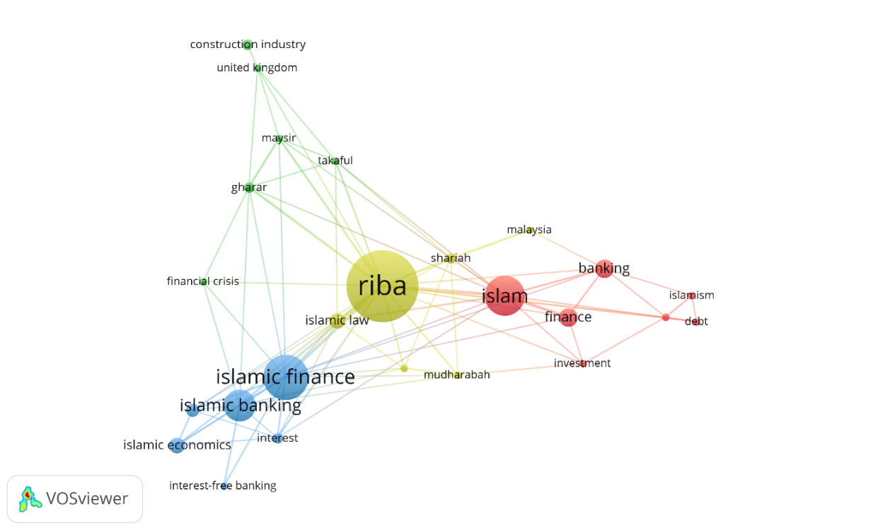

The descriptive data of terms co-occurrence from VOSviewer in Scopus are in four cluster as follows.

Table 2: Scopus Co-Occurrence Data Statistics

Figure 2: ProQuest Co-Occurrence Data Visualization

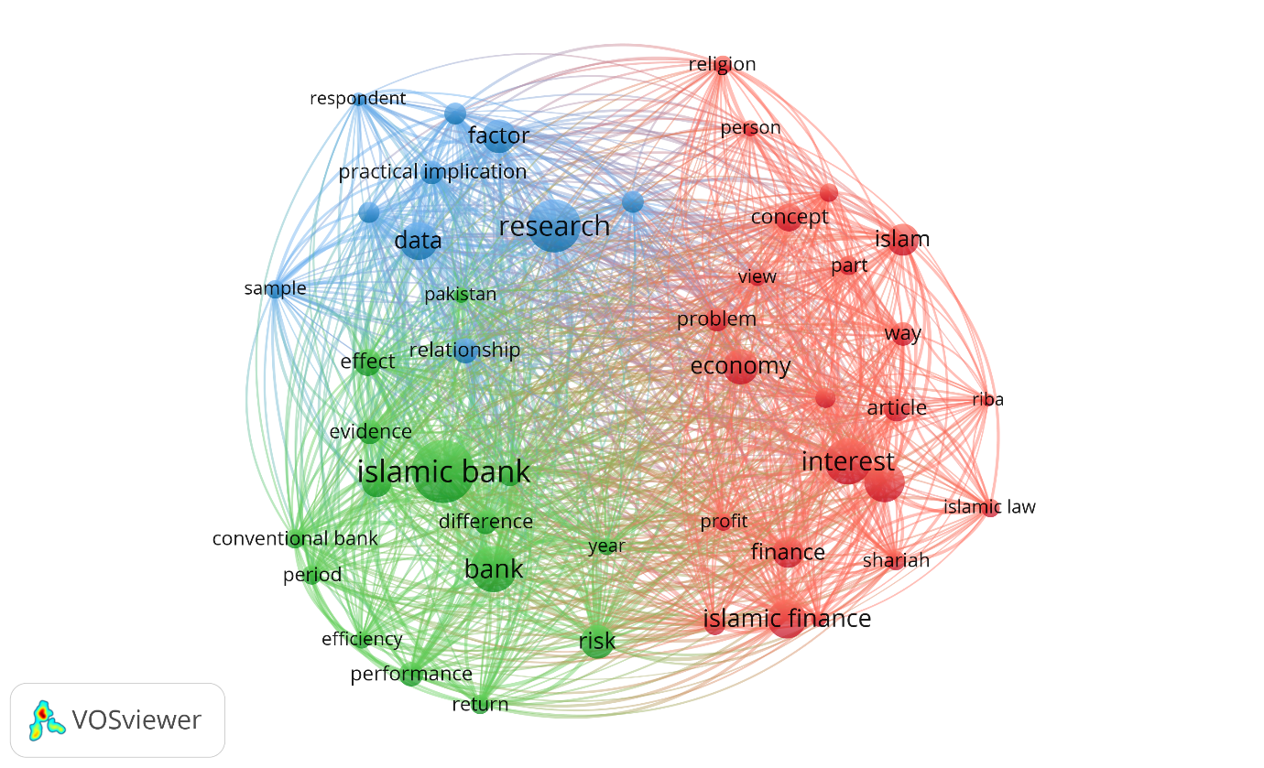

Table 3: ProQuest Co-Occurrence Data Statistics

Figure 3: ScienceDirect Co-Occurrence Data Visualization

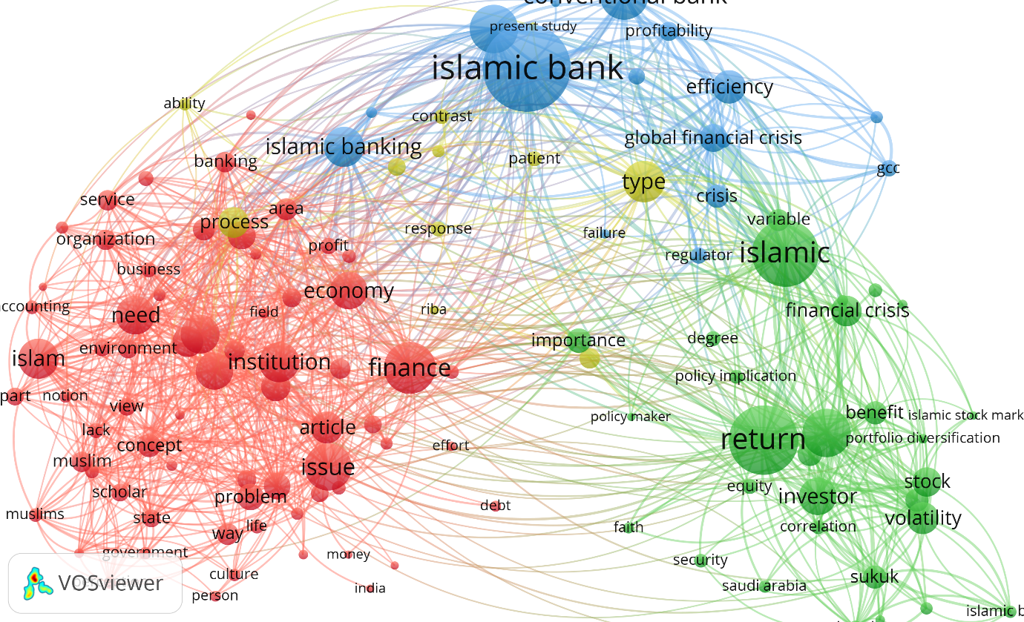

Table 4: ScienceDirect Co-Occurrence Data Statistics

ProQuest result differs significantly from Scopus, the term ‘banking’, ‘interest’ and ‘bank’ outnumbered the term riba itself. This is different from result in Scopus in which riba outnumbered the occurrence of ‘banking’ and ‘Islamic banking’. Result from ScienceDirect shows that from 313 citations, the term riba only appears once in the data corpus. Top authors from Scopus result shows the top five authors in riba research. Prof. Dato' Dr. Ahamed Kameel Mydin Meera is the Adjunct Professor at the Kulliyyah of Economics and Science, International Islamic University of Malaysia.

Author | Weight of Documents | Weight of Citations
Meera A.K.M. | 2 | 27
Al-Ajmi J. | 2 | 14
Al-Saleh N. | 2 | 14
Farooq M.O. | 2 | 6
Ghoul W.A. | 2 | 4
Abdullah A. | 3 | 3
Gracia Alonso F. | 2 | 2

In term of top journal researching riba topics, the International Journal of Islamic and Middle Esatern Finance and Management is the top of the rank.

Journal Title | Weight of Documents | Weight of Citations
International Journal of Islamic and Middle Eastern Finance and Management | 11 | 50
Journal of Islamic Accounting and Business Research | 5 | 16
Arab Law Quarterly | 9 | 14

6. Conclusions

Riba as a research subject is not a very big discussion among research community as compared to other Islamic knowledge research. As a comparison, a search for ‘halal’ in Scopus returns more than 1,000 result. The question of what constitute as riba, interest and usury is an never ending question. All three terms appear in Scopus research term co-occurrence, in ProQuest only one of three terms appear in the result findings; riba alongside Islamic finance and Islamic banking. In ScienceDirect, riba term only occure once in 313 citation result. Undoubtedly, Scopus as an international indexing database shows a more complete picture of what riba is about. In the Scopus result, we can see the term ‘gharar’ and ‘maysir’ appeared which elaborate on the concept of riba. In terms of riba free economy as the enabler of halal economy, this research has describe the discussion among researchers at the most authoritative level; Scopus indexed terms. The findings in this research provides descriptive data of what riba is about particularly as the halal economy agent.

7. Acknowledgement

This study is supported through the Institute of Research Management & Innovation (IRMI) Universiti Teknologi MARA, Malaysia.

8. References

Abdelaal, N. M., & Md Rashid, S. (2016). Grammar-Related Semantic Losses in the Translation of the Holy Quran, with Special Reference to Surah Al A’araf (The Heights). SAGE Open, 6(3). https://doi.org/10.1177/2158244016661750
Abdelaal, N. M., & Rashid, S. M. (2015). Semantic loss in the holy Qur’an translation with special reference to surah Al-WaqiAAa (Chapter of the event inevitable). SAGE Open, 5(4). https://doi.org/10.1177/2158244015605880
Ayub, M. (2007). Understanding Islamic finance. West Sussex, England: John Wiley & Sons.
Boehm-Bawerk, E. von. (2017). Capital and Interest: A Critical History of Economic Theory. Jazzybee Verlag
Bryson, B. (2015). The Mother Tongue, English and How it Got that Way. HarperCollins.
Caeiro, A. (2004). The social construction of shar’a : Bank interest, home purchase, and islamic norms in the west. Welt Des Islams, 44(3), 351–375. https://doi.org/10.1163/1570060042562516
Creswell, J.W. (2014). Research design: qualitative, quantitative, and mixed methods approaches (4th ed). Thousand Oaks, CA: SAGE Publications.
Haberler, G. (1946). Prosperity and Depression: A Theoretical Analysis of Cyclical Movements. New York: United Nations.
Harter, S. P. (1992). Psychological relevance and information science. Journal of the American Society for Information Science (1986-1998), 43(9), 602. Retrieved from http://search.proquest.com.ezaccess.library.uitm.edu.my/docview/216898031?accountid=42518
He, Q. (1999). Knowledge Discovery through Co-Word Analysis. Library Trends, 48(1), 133–159. Retrieved from http://eric.ed.gov/?id=EJ595487
Hjorland, B. (2001). Towards a theory of aboutness, subject, topicality, theme, domain, field, content and relevance. Journal of the American Society for Information Science and Technology, 52(9), 774-778. Retrieved from http://search.proquest.com.ezaccess. library.uitm.edu.my/docview/231480266?accountid=42518
Htay, S. N. N., & Salman, S. A. (2013). Introducing Takaful in India: An Exploratory Study on Acceptability, Possibility and Takaful Model. Asian Social Science, 10(1), p117. https://doi.org/10.5539/ass.v10n1p117
Hutchins, W.J. (1978). The concept of “aboutness” in subject indexing. Aslib Proceedings, 30, 172-181.
Kamali, M.H. (1989). Principles of Islamic jurisprudence. Petaling Jaya: Pelanduk Publications.
Kamla, R. & Alsoufi, R. (2015). Critical Muslim Intellectuals’ discourse and the issue of ‘Interest’ (riba): Implications for Islamic accounting and banking. Accounting Forum, 39(2), 140-154.
Kaye, A. (1992). Orthographic variation in Arabic loan words. English Today, 8(2), 32-41.
Mane, K. K., & Borner, K. (2004). Mapping topics and topic bursts in PNAS. Proceedings of the National Academy of Sciences, 101(Supplement 1), 5287–5290. https://doi.org/10.1073/pnas.0307626100
Noorzoy, M. S. (1982). Islamic law on riba (interest) and their economic implications. International Journal for Middle East Studies, 14, 3–17.
Qureshi, A.I. (1967). Islam and the theory of interest. Lahore: Sh. Muhammad Ashraf.
Rahman, A. (1979). Economic doctrines of Islam: Banking and insurance, vol. 4. London: MST.
Tieman, M. (2015). Halal clusters. Journal of Islamic Marketing, 6(1), 2–21. https://doi.org/10.1108/JIMA-05-2014-0034

