Halal Topic Journal Content Analysis in Journal of Islamic Marketing, British Food Journal and Meat Science
(10 pt blank line)
Muslim Ismail@Ahmad^{1*}, Mohd Nasir Ismail², , Roslina Othman³,
Mohd Saufi Ismail⁴
(10 pt bline)

¹Tengku Anis Library, Universiti Teknologi MARA Kampus Kota Bharu,
15050 Kota Bharu, Kelantan, MALAYSIA
muslim368@kelantan.uitm.edu.my
²Faculty of Information Management, Universiti Teknologi MARA Kelantan,
18500 Machang, Kelantan, MALAYSIA
nasir733@kelantan.uitm.edu.my
³Kulliyah of Information, Communication and Technology, International Islamic University Malaysia,
53100 Gombak, Selangor, MALAYSIA
roslina@iium.edu.my
⁴Academy of Contemporary Islamic Studies, Universiti Teknologi MARA Kampus Kota Bharu,
15050 Kota Bharu, Kelantan, MALAYSIA
saufi408@kelantan.uitm.edu.my
*Corresponding Author
(10 pt blank line)
(10 pt blank line)
Abstract: Journal of Islamic Marketing, British Food Journal and Meat Science are among the most productive journals publication in halal research. Data collection is from Scopus database, set for all available documents in each respective journals. Dataset in Journal of Islamic Marketing was 280 citations from 2010 to 2019. British Food Journal data (from 2010-2019) was 1,361 citations and Meat Science data was 1,852 citations (from 2014-2019). Scopus’s CiteScore, SCImago Journal Rank (SJR) and Source Normalized Impact per Paper (SNIP) is used to measure the journals. Papers of the highest citation each of respective journals from 2016-2018 are highlighted. This research utilizes VOSviewer for data visualization and GEPHI for data statistical analysis of words co-occurrence in titles and abstracts.. This research aims to analyse content in three journals specifically to identify subject relations or subject clusters in the article journals in 8 years span.

(10 pt blank line)
Keywords: Halal research, journal content analysis, bibliometric, VOSviewer

- Introduction

Journal of Islamic Marketing (JIM), British Food Journal (BFJ) and Meat Science (MS) are three most productive journal on halal topics. JIM articles are most in halal industry and consumerism such halal logistics and halal supply chain. BFJ and MS are mostly in halal meat authentication and halal forensics of meat products. Scopus metric, which is measurement and ranking used to numerate journals production is used. The measurement is CiteScore, SCImago Journal Rank (SJR) and Source Normalized Impact per Paper (SNIP). CiteScore is calculated based on the average citations received per document. CiteScore is the number of citations received by a journal in one year to documents published in the three previous years, divided by the number of documents indexed in Scopus published in those same three years.

Figure 1: Scopus CiteScore Calculation
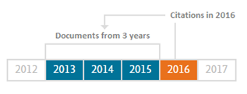

For example, the 2016 CiteScore counts the citations received in 2016 to documents published in 2013, 2014 or 2015, and divides this by the number of documents indexed in Scopus published in 2013, 2014 and 2015. SJR is weighted by the prestige of a journal. Subject field, quality, and reputation of the journal have a direct effect on the value of a citation.SJR assigns relative scores to all of the sources in a citation network. Its methodology is inspired by the Google PageRank algorithm, in that not all citations are equal. A source transfers its own 'prestige', or status, to another source through the act of citing it. A citation from a source with a relatively high SJR is worth more than a citation from a source with a lower SJR. SNIP takes into account characteristics of the source's subject field, which is the set of documents citing that source. SNIP especially considers the frequency at which authors cite other papers in their reference lists, the speed at which citation impact matures and the extent to which the database used in the assessment covers the field’s literature.

Table 1: Journal Titles, Coverage and Publication Years

No. | Title | Subject Coverage | Year in Publication
1. | Journal of Islamic Marketing | Nuances associated with Muslim consumption patterns, doing business in Muslim markets, and targeting Muslim consumers | 9 years
2. | British Food Journal | Social science, management and public health disciplines who are interested in food, as well as nutritionists and dietitians, food and agricultural companies | 115 years
3. | Meat Science | Interdisciplinary and international knowledge on all the factors which influence the properties of meat | 40 years

In terms of CiteScore, Meat Science outscored both BFJ and JIM by 50% respectively. Citations received by respective journals are headed by Meat Science by far, 3,256, outnumbering both BFJ and JIM by more than 70%. Document publication also headed by Meat Science by 961 counts to 500 of BFJ and a mere 71 of JIM. Score of SNIP also led by Meat Science with 1.9 score to 0.872 of BFJ and 1.422 of JIM. SJR also led by Meat Science with 1.643 score to 0.5 of BFJ and 0.355 of JIM.

Table 2: Journal Metric Year 2017
Title | CiteScore | Citations 2017 | Document  2014-16 | %Cited | SNIP | SJR
Meat  Science | 3.39 | 3,256 | 961 | 82 | 1.9 | 1.643
British  Food Journal | 1.7 | 849 | 500 | 65 | 0.872 | 0.5
Journal of Islamic  Marketing | 1.63 | 116 | 71 | 66 | 1.422 | 0.355

2. Methodology

This research used a mixed of qualititative and quantitative method in which bibliometric study is used. The research is an explonatory sequential model in which quantitative data precedes qualititative data, (Creswell, 2014). Datasets are journal titles from Scopus using its CiteScore, SJR and SNIP score for MS, JIM and BFJ. Citations are also retrieved for each journals, MS account for 1,852 citation for 5 years duration (2014-2019), BFJ account for 1,361 citations for 9 years duration and JIM account for 280 citations for 9 years duration. Total citations collected is 3,493 and a set of programs is used to analyse words co-occurrence. VOSviewer, GEPHI and Miscrosoft® Excel is used to analyse clusters of word co-occurrence. The following code was used in Scopus to retrieve the citations:

SRCTITLE(Journal of Islamic Marketing)

SRCTITLE(British Food Journal)

SRCTITLE(Meat Science)

This research is a journal content analysis, in which occurrence of words (technically the words are actually index terms) are enumerated according to frequency in the data collection. The dataset are from titles and abstracts which theoretically is the representation and summary of the whole paper is about. Thus, journal content co-word analysis provides a clearer picture of the past, current and potentially forecasting future research direction. Principally, co-word analysis is in essence a content analysis of multiple research papers that identify apparent patterns of co-occurrence in pairs of index terms. The significant of co-word analysis is that it allows clustering of ideas within the subject area and identifies the strength of associations between each terms based on their co-occurrence in dataset, (He, 1999; Mane & Borner, 2004). This research uses VOSviewer capability to analyse co-word analysis from Scopus comma separated value (csv) files. GEPHI and Microsoft® Excel are also used in the data analysis and findings. The research flowchart are as follows:

Figure 2: Research Flowchart

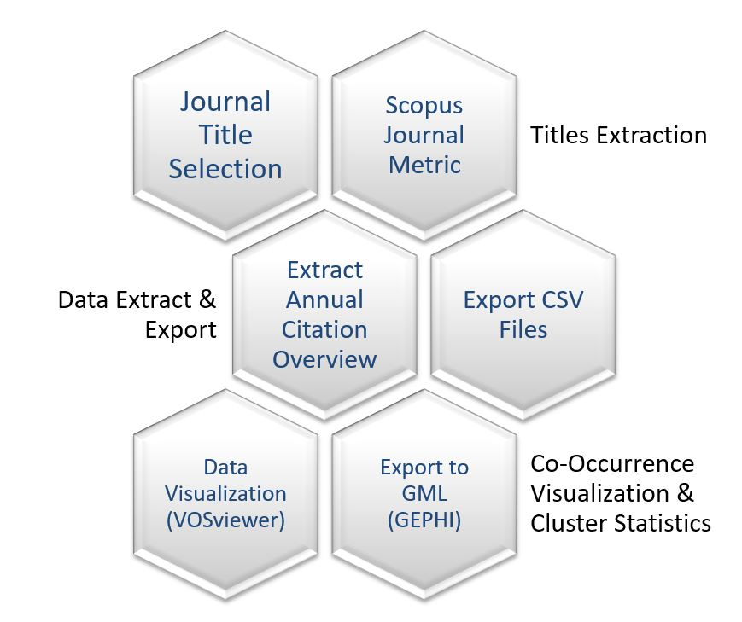

5. Highest Citation Papers

In this section, this research highlighted top six highest cited papers in the past three years, (2016, 2017 and 2018) from all three journals. The data is sorted according to the highest cited papers in descending order. The table below is the data of the highest citation papers detailing the titles, first author, times cited, journal title (JT), citation year (CY) and publication year (PY).

Table 3: Highest Cited Papers in Last Three Years

Title | 1st Author | Times Cited | JT | CY | PY
Natural antioxidants as food and feed additives to promote health benefits and quality of meat products: A review | Jiang, J. | 54 | MS | 2016, 2017,  2018, 2019 | 2016
Hyperspectral imaging with multivariate analysis for technological parameters prediction and classification of muscle foods: A review | Cheng, J. | 30 | MS | 2017, 2018, 2019 | 2017
Tradition and innovation in Italian wine family businesses | Vrontis, D. | 25 | BFJ | 2017, 2018, 2019 | 2016
What drives experiential loyalty? A case study of starbucks coffee chain in Taiwan | Wu, H. | 20 | BFJ | 2017, 2018, 2019 | 2017
Assessment of the stability of sheep sausages with the addition of different concentrations of origanum vulgare extract during storage | Fernandes, R. P. P. | 13 | MS | 2018, 2019 | 2018
Halal logistics opportunities and challenges | Zailani, S. | 12 | JIM | 2017, 2018, 2019 | 2017

The highest cited paper in the previous three years is by Jiang and Xiong (2016) on natural antioxidants as food and feed additives. The paper was cited 54 times in 2016 to 2019 and was published in Meat Science’s 120th 2016 volume. The second highest cited paper was also from Meat Science journal. The paper was authored by Cheng, Nicolai, and Sun (2017) about the technology parameters prediction and classification of muscle foods using hyperspectral imaging. In the context of halal research, Zailani’s (2017) papers is among the highest cited document from the journals in the last three years. Regardless, hyperspectral imaging is also used in halal forensics or halal authentication along with other technology particularly spectroscopy, polymerase chain reaction (PCR) and support vector machines (SVM).

6. Findings

Content in British Food Journal is more directed toward human related research in the last 9 years of its publication. As we can see from the data visualization and statistical table, the content of British Food Journal is constructed into four main themes, consumer, market research, research element and food management.

Figure 3: British Food Journal Co-Word Occurrence Visualization
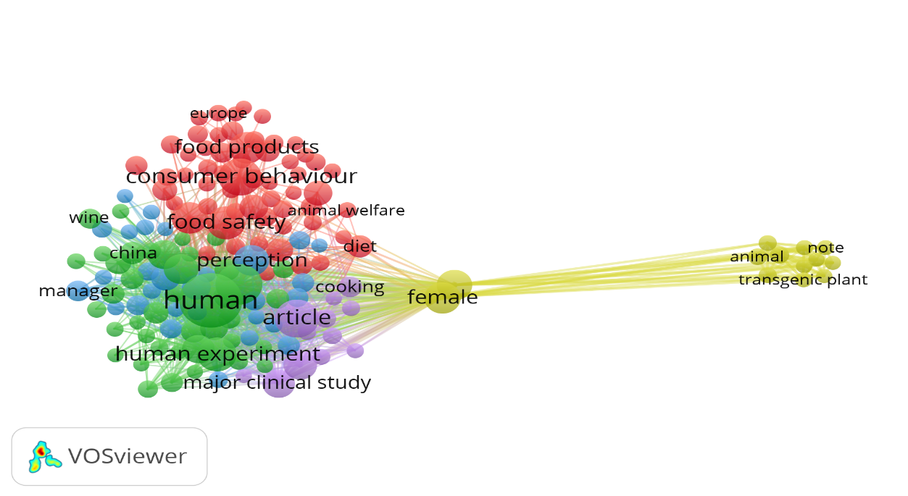

Table 4: British Food Journal Co-Word Occurrence Statistic

Meat Science content is largest dataset of the three journals and thus its data visualization showed the largest nodes of network. Regardless, the result shows four major themes; animal science, pork, forensics and consumer research .

Figure 4: Word Co-occurrence Visualization in Meat Science
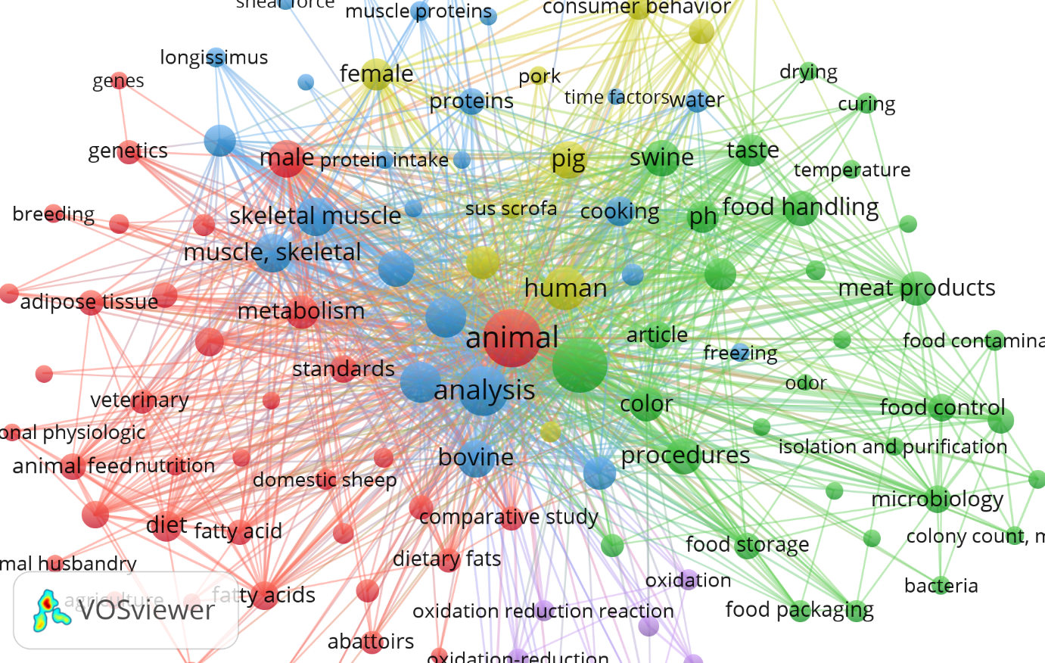

Table 5: Meat Science Co-Word Occurrence Statistic

Figure 5: Word Co-occurrence Visualization in Journal of Islamic Marketing
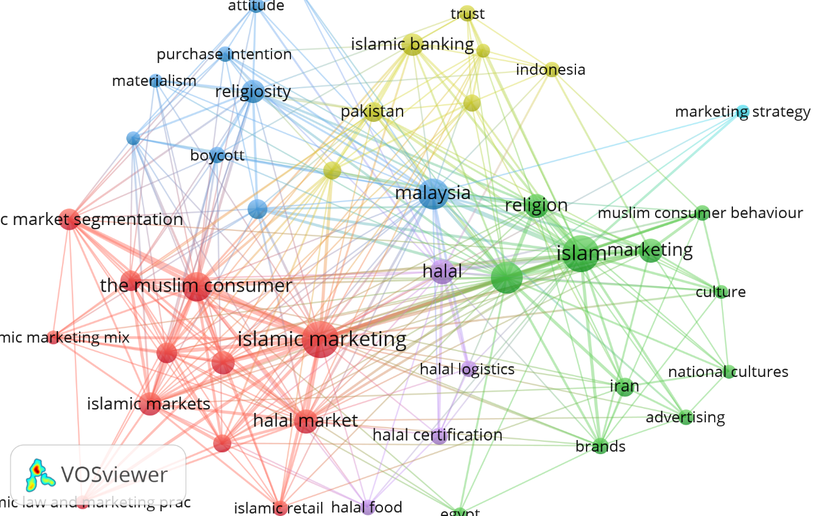

Table 6: Journal of Islamic Marketing Co-Word Occurrence Statistic

Journal of Islamic content in the last 9 years has shown topics which focus on marketing, Islam, consumer related, finance and halal. In terms of halal topics, halal themes are an apparent research cluster and also in the marketing cluster.

6. Conclusions

In the context of halal research, crosscheck of halal research in Scopus search using the following string, TITLE-ABS-KEY ( halal ) AND ( LIMIT-TO ( EXACTSRCTITLE , "Journal Title")) showed that British Food Journal content in halal topics are mostly related to human and Malaysia. Meat Science crosschecks showed halal research topics are mostly on animal and meat.

Table 7: BFJ and MS Crosscheks
Journal Title | Highest Frequent Keyword
British Food Journal | Human (14),  Malaysia (10),  Article (8),  Certification (8),  Halal (8)
Meat Science | Animal (64),  Meat (53),  Abbatoir (21),  Slaughterhouse (21),  Halal (14)

Journal of Islamic Marketing showed a more precise and representative of the halal food science and halal industry. The halal research topics are apparently clustered into four major themes, which is marketing of halal products/services, Islamic knowledge element, research works and the halal food industry itself.

Figure 7: JIM Crosschecks

This research has analysed the content of three Scopus indexed journal and revealed apparent themes of research subject in each respective journal. British Food Journal main theme centers around human related topics, Meat Science main theme centers around animal research topics and Journal of Islamic Marketing main theme is Islamic marketing research subjects. In terms continuity, Meat Science is the longest existing journal among the three, exceeding a century of research publishing. Meat Science also outscored both other journals in the Scopus CiteScore. In the analysis of highest cited paper in the last three years, Meat Science papers are first and second respectively.

7. Acknowledgement

This study is supported through the YaPIEM Management Academy (AKADEMI) granted from the Akademi Pengurusan YaPEIM Sdn. Bhd. and Institute of Research Management & Innovation (IRMI) Universiti Teknologi MARA, Malaysia (100-IRMI/GOV 16/6/2 (001/2018)).

9. References

Cheng, J. H., Nicolai, B., & Sun, D. W. (2017). Hyperspectral imaging with multivariate analysis for technological parameters prediction and classification of muscle foods: A review. Meat Science, 123, 182–191. https://doi.org/10.1016/j.meatsci.2016.09.017
Creswell, J.W. (2014). Research design: qualitative, quantitative, and mixed methods approaches (4th ed). Thousand Oaks, CA: SAGE Publications.
Elsevier. (2019). The largest database of peer-reviewed literature - Scopus | Elsevier Solutions. Retrieved March 8, 2019, from https://www.elsevier.com/solutions/scopus
Fernandes, R. P. P., Trindade, M. A., Lorenzo, J. M., & de Melo, M. P. (2018). Assessment of the stability of sheep sausages with the addition of different concentrations of origanum vulgare extract during storage. Meat Science, 137, 244-257. doi:10.1016/j.meatsci.2017.11.018
He, Q. (1999). Knowledge Discovery through Co-Word Analysis. Library Trends, 48(1), 133–159. Retrieved from http://eric.ed.gov/?id=EJ595487
Jiang, J., & Xiong, Y. L. (2016). Natural antioxidants as food and feed additives to promote health benefits and quality of meat products: A review. Meat Science, 120, 107–117. https://doi.org/10.1016/j.meatsci.2016.04.005
Lancaster, F. W. (2003). Indexing and abstracting in theory and practice. Champaign, IL: University of Illinois.
Mane, K. K., & Borner, K. (2004). Mapping topics and topic bursts in PNAS. Proceedings of the National Academy of Sciences, 101(Supplement 1), 5287–5290. https://doi.org/10.1073/pnas.0307626100
Nicolaisen, J., & Hjørland, B. (2006). Practical potentials of Bradford's law: A critical examination of the received view. Journal of Documentation, 63(3), 359-377. doi:http://dx.doi.org/10.1108/00220410710743298
Qaraḍāwī, Y. (2007). The lawful and the prohibited in Islam: (Al-Halāl wal Harām fil Islām). New Delhi: Kitab Bhavan.
Tamine-lechani, L., Boughanem, M., & Daoud, M. (2010). Evaluation of contextual information retrieval effectiveness: Overview of issues and research. Knowledge and Information Systems, 24(1), 1-34. doi:http://dx.doi.org/10.1007/s10115-009-0231-1
Tieman, M. (2015). Halal clusters. Journal of Islamic Marketing, 6(1), 2–21. https://doi.org/10.1108/JIMA-05-2014-0034
Vrontis, D., Bresciani, S., & Giacosa, E. (2016). Tradition and innovation in Italian wine family businesses. British Food Journal, 118(8), 1883–1897. https://doi.org/10.1108/BFJ-05-2016-0192
Wu, H.-C. (2017). What drives experiential loyalty? A case study of Starbucks coffee chain in Taiwan. British Food Journal, 119(3), 468–496. https://doi.org/10.1108/BFJ-08-2016-0349

